Instructions for Data Set Configuration:

1. Install MS SQL Server (latest Version would be more preferrable)
2. Install SQL Server Management Studio (latest version would be more preferrable)
3. Once both are installed, Keep the attached .bak file in the below path (Note: if the provided file may be corrupted, please download the actual dataset from the path <https://github.com/microsoft/powerbi-desktop-samples/blob/main/DAX/Adventure%20Works%20DW%202020.bak>)

**C:\Program Files\Microsoft SQL Server\MSSQL16.MSSQLSERVER\MSSQL\Backup**

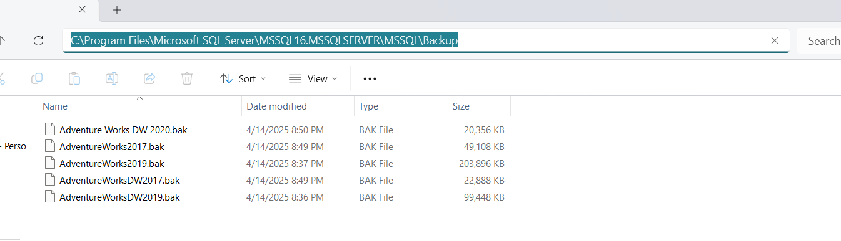

1. Open SQL Server Management Studio. Then attach the DB as below steps:

Right Click Databases->Restore Database

Select Device-> Click on three dots on the Right hand side

A Pop Up window opens. Click on Add and Navigate to **C:\Program Files\Microsoft SQL Server\MSSQL16.MSSQLSERVER\MSSQL\Backup**

Select the Database to be Restored

Click on OK.

Make Sure the Import has been showing “Done” as below and Click on OK to attach the db to the SSMS.

Restored DB should be Shown as below:

Instructions for Power BI Report Configuration:

1. Install Power BI Desktop (if it is not done already)
2. Open the Report Adventurework Analyze in Power BI desktop (It will ask you to login if in case using Power BI Desktop for first time. Provide your Tiger ID and PW to login)
3. To make the report working, Change or Edit the Parameters as below:



